**Morgan State University**

Quantum Laboratory Sequence

Quantum Lab #4: Two-Photon Interference

**Reference: Textbook Section**

**Motivation**

[For Eric]

**Background**

In 1987, Hong, Ou and Mandel (HOM) proposed and demonstrated a quantum interference effect of two photons that has no classical physics counterpart: When two *indistinguishable* photons combine at a non-polarizing beam splitter at exactly the same time, they always leave together along just one output port of the beam splitter, as shown in Fig. 1.

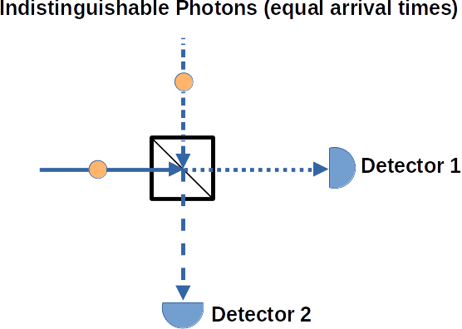

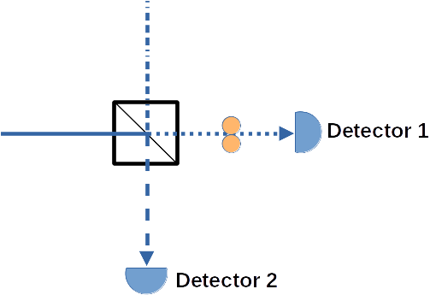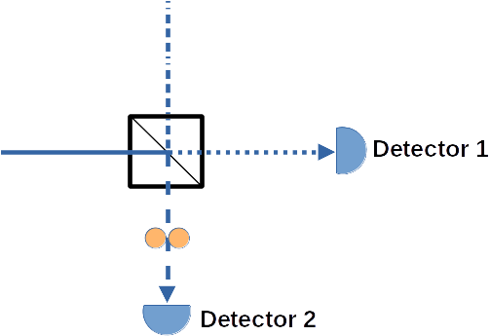**Figure 1.** When two photons enter a beam splitter simultaneously (indistinguishable), only two possibilities exist at the output ports: (1) two photons to Detector 1 or (2) two photons at Detector 2.

However, if the two photons arrive at slightly different times at the beam splitter, and are thus *distinguishable*, each photon will either reflect or transmit in the splitter, independent of the other. Half of the time these two distinguishable photons will (independently) exit along the same port, and half of the time these photons will (independently) exit out separate ports, as shown in Fig. 2. Only in the indistinguishable case will *both* photons *always* exit together out one port as a pair.

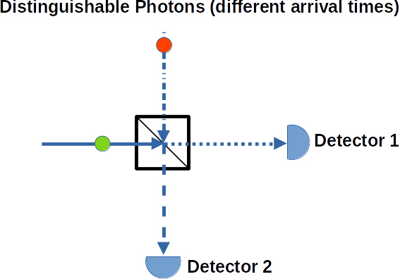

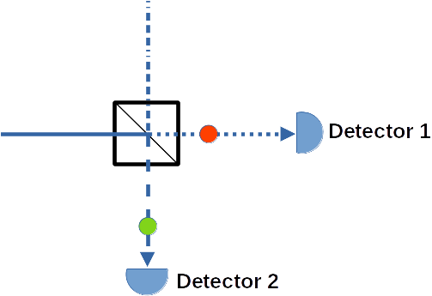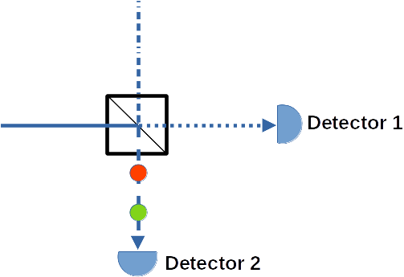

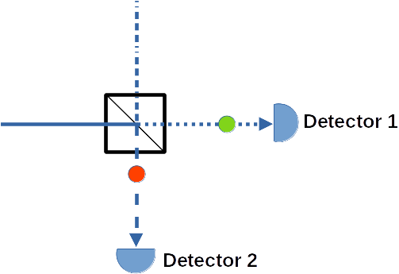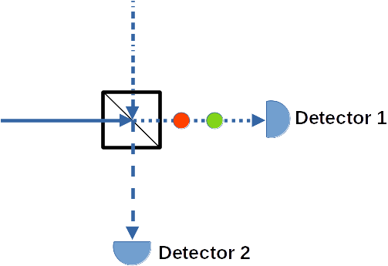**Figure 2.** When two photons enter a beam splitter at different times (distinguishable), four possibilities exist at the output ports: (1) two photons to Detector 1; (2) two photons at Detector 2; (3) late photon at Detector 1 and early photon at Detector 2; or early photon at Detector 1 and late photon at Detector 2.

To better understand how a single photon will behave through a beam splitter, some quantum operator theory is helpful. Consider the four ports of a beam splitter as shown in Fig. 3. Let the quantum state be represented as a "ket" containing the number of photons. For example, port 1 with zero photons is represented as. Let the quantum "annihilation" operatorrepresent the loss of a photon. For example, assume port 1 has one incoming photon, represented as. The removal of this photon is done by operating on this state by annihilation operator, namely. Note that the subscripts should match to keep track of the operator on specific ports. To create a photon, we use the photon "creation" operator , which is the adjoint of. For example, to create another photon into port 1, the equation is, which shows that now port 1 has 2 photons entering it.

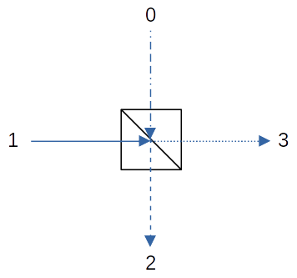**Figure 3.** Illustration of a beam splitter with four ports labeled 1, 2, 3 and 4. Ports 0 and 1 are input ports and ports 2 and 3 are output ports.

An amazing fact is that photons can be created out of the vacuum, and in fact this quantum vacuum is a necessary aspect of quantum mechanics, including the explanation for spontaneous emission. The equation to create a photon from the vacuum entering port 1, for example, is.

Now, let's investigate how a single photon entering a beam splitter will behave. To start, assume only vacuum at all ports, i.e.,,,and. Let's create a single photon entering port 1, and assume vacuum at port 0:

(1)

As you can see, the creation operatoroperates on the vacuum stateassociated with port 1, but not on port 0, which is still the vacuum state.

Referring again to Fig. 3, the creation operator for the output port 2 depends on the photon entering the beam splitter from ports 0 and 1, namely

(2)

and similarly for output port 3:

(3)

The imaginary *i* stems from the reflection off the dielectric coating inside the beam splitter.

Now we can use Eqs. (2) and (3) to solve forandin terms of and :

(4a)

(4b)

Note that we have set specific times *t*0 and *t*1 for these creation operators.

The relation connecting the ports of the beam splitter can be written as

(5)

Now we can multiply both sides of Eq. (5) by , and using Eqs. (4):

(6)

The first term of Eq. (6) is the creation of 2 photons at port 2 (at slightly different times) and the second term is for 2 photons created at port 3 (at slightly different times). Similarly, the third and fourth terms of Eq. (6) represent the creation of single photons at both ports 2 and 3 at slightly different times. Equation (6) thus represents the four options shown in Fig. 2. Now, let's assume that while times *t*0 and *t*1 are different, they both occur within the coincidence measurement time of our detection system. Per Eq. (6), each of the four options are equally probable, but only the third and fourth terms can allow for a "coincident counts". Since for the first and second terms there are two photons in either port, no coincidences are possible in those cases. Therefore, we should see coincidence counts about 50% of the time.

Now, assume the arrival times at the beam splitter are coincident (i.e. indistinguishable) at time *t*0, then Eq. (6) becomes

(7)

Equation (7) shows us that we will either detect 2 photons at port 2, or 2 photons at port 3, but never will photons arrive at both ports simultaneously. Coincidence counts for ports 2 and 3 are therefore zero, and we have proved the scenario of Fig. 1.

**Lab Setup**

1. First, optimize the source photon counts by adjusting the fiber collimator horizontal and vertical controls on the quED platform for each leg (quED 1 and quED 2) such that there are 50,000-100,000 counts for each. There should also be significant (1,000s) of coincident counts (button "01" is selected on the quCR display).
2. Per Fig. 4, use a fiber optic coupler to connect the fiber optic labeled "HOM 1/ to quED 1" from the HOM assembly to the "quED 1" fiber optic emanating from the quED quED box. Similarly, use another fiber optic coupler to connect the fiber optic labeled "HOM 2/ to quED 2" from the HOM assembly to the "quED 2" fiber optic emanating from the quED quED box.
3. The motor ethernet cable from the HOM motor should be connected to port #3 of the qu3MD box.
4. Each of the quED outputs is connected to one of the inputs of the quED-HOM. We remove the wave plate from the pump beam of the quED, so that we generate indistinguishable non-entangled photon pairs. Now, we can introduce a temporal delay between the two photons by moving one of the fiber collimators in the quED-HOM. This makes the two photons distiguishable (you can say, one photon arrives at the beam splitter “earlier than the other”). We use this to demonstrate the so-called Hong-Ou-Mandel dip in coincidence counts, by tuning the delay between the two photons.

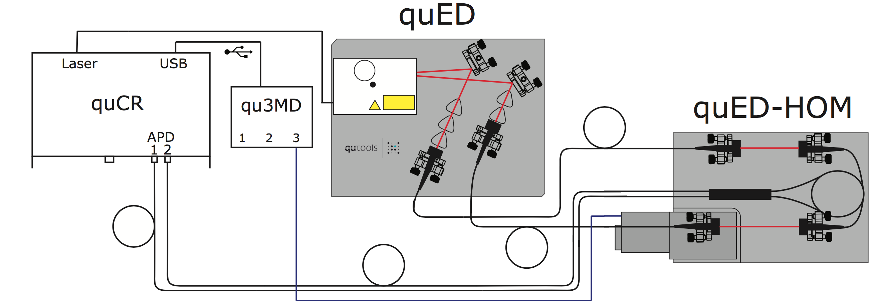**Figure 4.** The setup of the two-photon HOM experiment with all necessary connections.

**Experimental**

**Optimize interferometer alignment**

1. Place a card in the path of one of the free-space beams of the HOM platform (see Fig. 5), and adjust the other (unblocked) leg to maximize the counts displayed in the quCR LCD screen. To do this, adjust the fiber collimator collection knobs:
   1. Make very slight rotations of the lower (horizontal adjust) knob followed by a very small rotation of the upper (vertical adjust) knob to see whether counts go up or down.
   2. Iterate this process until achieve maximum possible counts.
2. Next, place the card over the other free-space beam, and do the same knob adjustments for that path's fiber collimator. Ideally, the counts of both legs should be about the same (within 1,000 to 3,000 counts).
3. Ensure there are 1,000s of coincident counts (button "01" is selected on the quCR display).

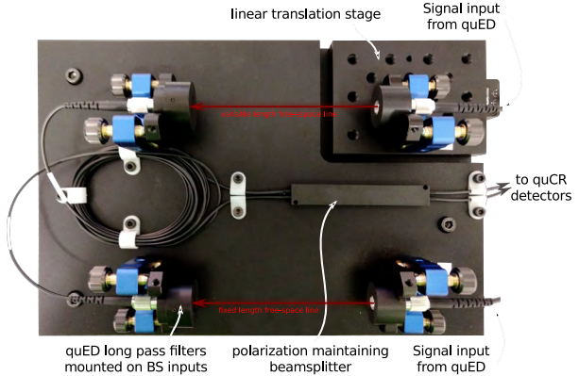**Figure 5.** Illustration of the quED-HOM platform showing the free-space beams for both the static arm (lower) and adjustable arm (upper).

**Identify the coincidence dip**

1. On the quCR main instrument, press the quApp icon  to the quCNT "linear scanning" page (see Fig. 6).

Coarse Search

2. Referring to Fig. 6, first conduct a coarse search for the coincident dip. For this, set the menu items in the lower part of the quCR screen to the values shown in Table 1.

**Table 1.** Linear scanning settings to coarsely search for the coincidence dip.

|  |  |  |
| --- | --- | --- |
| chan = 01 | Position = - 2.0 mm (approx) | Target = +2.0 mm (approx) |
| stage = quED-HOM | Stepsize = 10/3200 (=3.1 mm) | integration = 0.1 sec |

3. Press the Start icon on the quCR display

The motor should then automatically move linearly from Position (i.e. negative 2 mm) to Target (i.e. positive 2 mm) in steps of 3.1 mm. This measurement will take several minutes. If successful, a narrow dip should be observed. **Note the motor position of the C*oarse dip*** (e.g. - 0.14 mm in Fig 6, but will depend on your particular experiment result).

Fine Search

4. Referring to Fig. 6, for the fine search of the coincident dip, set the menu items in the lower part of the quCR screen to the values shown in Table 2.

**Table 2.** Linear scanning settings to coarsely search for the coincidence dip.

|  |  |  |
| --- | --- | --- |
| chan = 01 | Position = ***Coarse dip*** - 0.03 mm | Target = ***Coarse dip*** + 0.03 mm |
| stage = quED-HOM | 1/3200 (=0.3 mm) | integration = 2.0 sec |

5. Press the Start icon on the quCR display

If done correctly, you should see a result similar to Fig. 6.

Write down the following from the quCR screen:

1. Upper, flat coincident count rate (e.g. 18,000 counts in Fig. 6)___________________
2. Lowest counts of the dip (e.g. 2,500 counts in Fig. 6)__________________________
3. The FWHM of the dip (e.g. about 0.005 mm in Fig. 6)_________________________

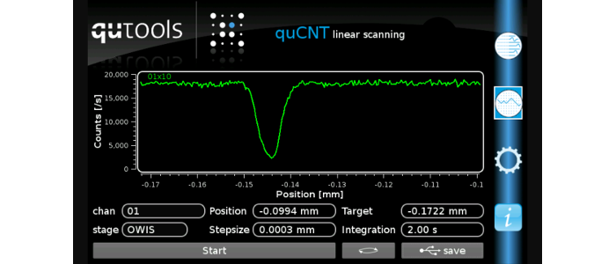**Figure 6. Coincident dip for the fine-tuned HOM experiment**

**Discussion**

1. Convert the FWHM value you measured from distance (mm) into seconds, using the speed of light (3x1011 mm/sec) in the conversion. Change the units from seconds to femtoseconds (1 sec = 1015 femtoseconds). Using this information, how "simultaneous" do the entering photons need to arrive together to start to be considered indistinguishable?

2. Calculate the visibility of the dip (max - min/ max + min). Ideally, the visibility of the coincidence dip should be 1.0. Comment on why your measured visibility is less than 1.0.

3. Note that all of our discussions above assumed single photons, but we are using a continuous wave (CW) laser (millions of photons per second). The use of APDs, which trigger on arrival of a single photon, act to create a "single photon"-like scenario. Think about what it means to adjust the path length of one arm of the HOM such that we still get no coincidence counts, even though we actually have a beam of many photons. Comment on your thoughts how this coincidence dip is still occurring with a CW laser.